1a)
%{
#include<stdio.h>
int a[]={0,0,0,0},opnd=0,valid=1,i=0;
void ext();
%}
%x oper
%%
[a-zA-Z0-9]+ {opnd++;BEGIN oper;}
<oper>"+" {if(valid){valid=0;i=0;} else ext();}
<oper>"-" {if(valid){valid=0;i=1;} else ext();}
<oper>"*" {if(valid){valid=0;i=2;} else ext();}
<oper>"/" {if(valid){valid=0;i=3;} else ext();}
<oper>[0-9a-zA-Z]+ {opnd++; if(valid==0){valid=1;a[i]++;}}
<oper>"\n" {if(valid==0)ext(); else return 0;}
.|\n {ext();}
%%
void ext()
{
printf("Invalid expression");
exit(0);
}
int yywrap(void){return 0;}
int main()
{
printf("Input expression");
yylex();
printf("No of identifiers are %d\n",opnd);
printf("No of operators + are %d\n",a[0]);
printf("No of operators - are %d\n",a[1]);
printf("No of operators * are %d\n",a[2]);
printf("No of operators / are %d\n",a[3]);
}

Output:
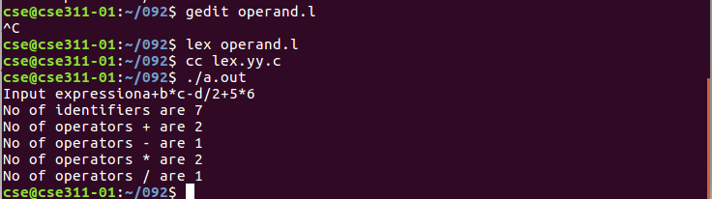
2) To recognize a string ending with b and preceeded by n a’s
lex program

%{
#include<stdio.h>
#include"y.tab.h"
%}
%%
a {return A;}
b {return B;}
\n {return yytext[0];}
. {return yytext[0];}
%%

yacc program

%{
#include<stdio.h>
int yyerror();
int yylex();
%}
%token A B
%%
str:s'\n' {printf("Valid Expression");}
;
s:x B
;
x:x A | A
;
%%
int yywrap()
{
return 0;
}
int main()
{
printf("Enter input string\n");
if(!yyparse())
{
printf("Valid String");
return 0;
}
}
int yyerror()
{
printf("Invalid input string");
return 0;
}

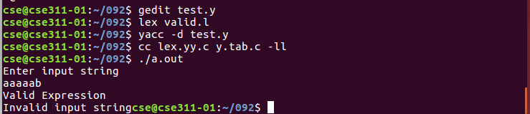

6)
Soln)
%{
#include<stdio.h>
int count=0;
%}
op[\+\-\*\/\=]
nop[\,\;]
digit[0-9]
letter[a-zA-Z]
id{letter}+|({letter}{digit})+
nid({digit}{letter})+
%%
("if")|("for")|("int") {printf("Keywords %s",yytext);}
{id} {printf("Identifiers %s",yytext);count++;}
{op} {printf("Operator %s",yytext);}
{nop} {printf("Not an operator %s",yytext);}
{nid} {printf("Not an identifier %s",yytext);}
%%
int yywrap(){}
int main()
{
FILE *fp;
char file[10];
printf("Enter the file name\n");
scanf("%s",file);
fp=fopen(file,"r");
yyin=fp;
yylex();
printf("The no of identifier are %d",count);
return 0;
}

Output:
